Question 18:
Create a dictionary with five languages and the country where they are spoken. Update one country.
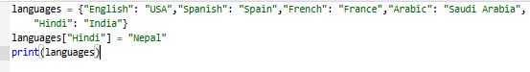
Output:
